QUICK SORT
1. Introduction
Quick Sort is a highly efficient divide-and-conquer algorithm that selects a 'pivot' element and partitions the array around it. All elements smaller than pivot go to left, greater to right.
2. Algorithm Visualization
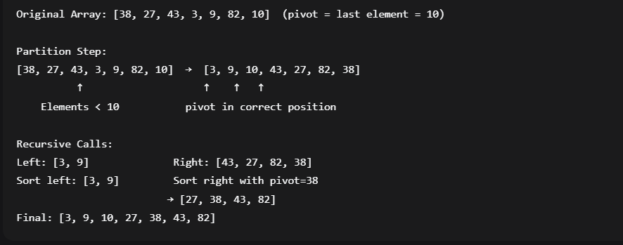
3. Complete C++ Implementation
quickSort.cpp
4. Complexity Analysis
Complexity | Best Case | Average Case | Worst Case
Time | O(n log n) | O(n log n) | O(n²)
Space | O(log n) | O(log n) | O(n)
When Worst Case Occurs:
- Already sorted array (with first/last element as pivot)
- Reverse sorted array
- All elements equal (can be optimized)
Recurrence Relation:
- Best: T(n) = 2T(n/2) + O(n) → O(n log n)
- Worst: T(n) = T(n-1) + O(n) → O(n²)
5. Step-by-Step Trace Example
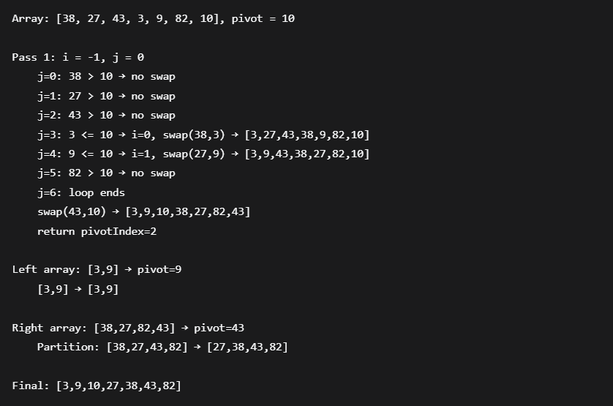6. Pivot Selection Strategies
cpp
// Strategy 1: First element as pivot
int pivot = arr[low];

// Strategy 2: Last element as pivot (used above)
int pivot = arr[high];

// Strategy 3: Middle element as pivot
int mid = low + (high - low) / 2;
swap(arr[mid], arr[high]);
int pivot = arr[high];

// Strategy 4: Median-of-three (most balanced)
int medianOfThree(vector<int>& arr, int low, int high) {
int mid = low + (high - low) / 2;
if (arr[mid] < arr[low]) swap(arr[low], arr[mid]);
if (arr[high] < arr[low]) swap(arr[low], arr[high]);
if (arr[high] < arr[mid]) swap(arr[mid], arr[high]);
swap(arr[mid], arr[high]); // Place median at end
return arr[high];
}
7. Optimized Quick Sort with Hybrid Approach
cpp
void optimizedQuickSort(vector<int>& arr, int low, int high) {
// Use insertion sort for small subarrays
if (high - low + 1 <= 10) {
insertionSort(arr, low, high);
return;
}

if (low < high) {
int pivotIndex = randomizedPartition(arr, low, high);
optimizedQuickSort(arr, low, pivotIndex - 1);
optimizedQuickSort(arr, pivotIndex + 1, high);
}
}
8. Advantages & Disadvantages
Advantages:
- ✅ In-place sorting (O(log n) extra space)
- ✅ Cache-friendly (sequential memory access)
- ✅ Excellent average performance
- ✅ Tail recursion can be optimized
Disadvantages:
- ❌ Unstable sorting algorithm
- ❌ O(n²) worst-case time complexity
- ❌ Not suitable for linked lists
- ❌ Requires good pivot selection

